6.9: a) (i) Tension force is always perpendicular to the displacement and does no work.
(ii) Work done by gravity is 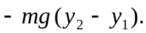 When 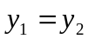, 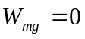.
b) (i) Tension does no work.
(ii) Let l be the length of the string.
The displacement is upward and the gravity force is downward, so it does negative work.

